









































**Immunisation**

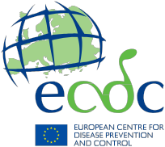

**Information for parents and caregivers**

**Evaluating Internet sources of immunisation information**

**Find your way to high quality information**

The use of the Internet as a source of health-related information is growing rapidly. It may sometimes be difficult to judge the quality and accuracy of the information found. Here you will find some suggestions on what to consider when searching the web for information related to immunisation.

**Check the website’s ownership, purpose, authors, and organisations that support it. Websites offering credible information are transparent with the way they work. They usually have a section where they inform visitors if they are commercial or non-profit, independent or affiliated. Websites should also be transparent about their sources of funding and inform about data protection.**

**A website should clearly state who is responsible for its content. It should also identify the organisations(s) behind it (e.g. ‘about us’) and provide contact information.**

**Credible websites usually present both the benefits and risks of vaccination.**

For more information on immunisation, please visit vaccination- related websites of your national public health organisations. You can also access information on immunisation on the websites of the European Centre for Disease Prevention and Control (ECDC) and the World Health Organization (WHO). The WHO Global Advisory Committee on Vaccine Safety (GACVS) developed four categories of criteria for good information practices – credibility, content, accessibility and design – to which websites providing information on vaccine safety should adhere. WHO evaluates websites for adherence to these criteria, and you can find more information on their website with links to some websites in different languages that have been reviewed. You will find specific links on the last page of this leaflet.



**Check that the website ...**

● is clear about its mission and purposes

● provides information based on scientific research and mentions the sources of information, including references and links

● directs you to additional information sources and refers to well-recognised organisations and professional bodies in the public health field

● is regularly updated

● asks the user’s specific affirmative consent when using personal data

● informs the user of any use of data provided

***Discuss your findings with your healthcare provider and ask for his/her advice.***

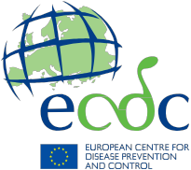

**Information resources on vaccines and immunisation**

ECDC vaccination gateway [ecdc.europa.eu/en/eurovaccine](http://ecdcsp2010/en/eurovaccine)

World Health Organisation (WHO) – Lists of reviewed vaccination websites that meet good information practices criteria

[www.who.int/vaccine_safety/initiative/communication/network/approved_vaccine_safe- ty_website/en](http://www.who.int/vaccine_safety/initiative/communication/network/approved_vaccine_safety_website/en)

**Further link recommendations** *(insert as appropriate)*

Link description max two lines

Link

Link description max two lines

Link

**Vaccination protects you and your family. By vaccinating you contribute**

**to a healthy community.**