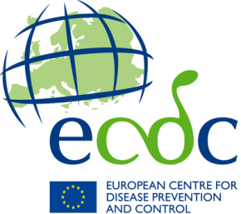

**ECDC** TECHNICAL DOCUMENT

**Office of the Director, International Relations Section**

**Template: assessment team meetings**

Assessing communicable disease control and prevention  
 in EU enlargement countries



5.5 Template: assessment team meetings

EU Assessment team plus national authorities and competent institutions

Date: [00 Month 2099]

Agenda

09:00 Welcome and introduction

09:15 – 10:45 Introductions to provinces

(5 min/team, headlines about the province and its health/public health systems)

10:45 – 11 30 Thematic system reviews (by section): surveillance and control, microbiology (Sections 3 and 5)

11:30 Coffee

11:45 –12:15 Thematic system reviews (by section): emergency response (Section 4), disease programmes (Section 6), governance and human resources (Sections 1 and 2)

12:15 – 12:30 Synthesis; items to take to national week

12:30 – 13:00 National week assessment

13:00 Lunch

14:00 – 16:00 Meeting wrap-up

|  | Name | Signature |
| --- | --- | --- |
|  | External experts | |
| 1 |  |  |
| 2 |  |  |
| 3 |  |  |
| 4 |  |  |
| 5 |  |  |
| 6 |  |  |
|  | ECDC staff | |
| 1 |  |  |
| 2 |  |  |
| 3 |  |  |
| 4 |  |  |
| 5 |  |  |
| 6 |  |  |
| 7 |  |  |
| 8 |  |  |
| 9 |  |  |
|  | EU and other institutions | |
| 1 |  |  |
| 2 |  |  |
| 3 |  |  |