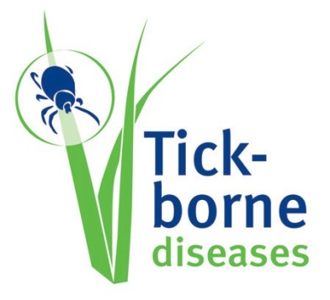

Information sheets for the general public living in endemic areas

Tick-borne encephalitis
Information for the public on tick-borne diseases
Ticks can pass on diseases
Ticks are very small and live on the blood from pets, farm and wild animals but they can also bite humans who pass through their living environment.
Tick bites are not dangerous in themselves. However, some ticks are infected with bacteria, viruses or parasites that can cause serious diseases in humans so there is a risk that these ticks may pass on their infection to you as they feed on your blood.
Tick-borne diseases in [country]
In [country], a tick-borne disease to be aware of is Tickborne encephalitis which can occur in areas where infected ticks that transmit the disease are found. Ticks thrive in shady and humid woodland, clearings with grass, open fields and bushes. They live in both rural and urban locations. The main risk zones are [endemic regions in country].
About ticks
Ticks live in the ground vegetation and move mainly by climbing up plants and walking on the ground. They latch on to a passing animal or human host by using hooks on their legs.
Adults: 7 -15 mm
Nymphs: 2 -3.5 mm
Larvae: 0.5 – 1mm
Illustration is only indicative. Sizes can vary from 0.5 to 15 mm, depending on tick species.
Ticks’ life cycles go through four stages: egg, larva, nymph and adult. During the last three stages the tick may bite and can transmit disease.
To the naked eye the larvae look like specks of dust, while nymphs are slightly larger, pinhead or poppy seed size. Adult ticks have eight legs and are the size of small spiders. The adult ticks can also vary in colour, from reddish to dark brown or black. Once fed, a female tick can grow to the size of a pea, as its body fills with blood.
> For more information on tick-borne diseases, please consult the ECDC website www.ecdc.europa.eu
> Tick-borne encephalitis
If you have been bitten by a tick and you experience any of the following symptoms within four weeks after the bite, please contact your doctor as you may have contracted Tickborne encephalitis:
• Fever
• Tiredness
• Headache
• Muscle pain
• Nausea
The later phase of the disease involves the central nervous system and can result in long-term neurological symptoms, and in some rare cases even death.
It is possible to be vaccinated against Tick-borne encephalitis. Ask your doctor for more information.
Tick-borne diseases in Europe
Tick-borne diseases can be found almost all over Europe, with some diseases being more prevalent in certain regions.
Inform yourself on areas where tick-borne diseases are present and ask your doctor regarding necessary precautionary measures before travelling to any of these areas, especially if you plan to engage in outdoors activities (camping, hiking, hunting, lake or river fishing, etc.) during your visit that might increase your exposure to ticks.
[Name and contact details of health authorities]
Preventive measures
Tickborne encephalitis can be prevented by:
- using repellents on your skin and clothes (clothes specific insect repellents should not be used on the skin)and protective clothing that will help prevent tick bites
- after being outdoors, remove your clothes outside and expose them to the sunlight or wash them
- in areas where TBE is endemic, vaccination against Tick-borne encephalitis is also recommended
- removing ticks quickly to lower the risk of infection

