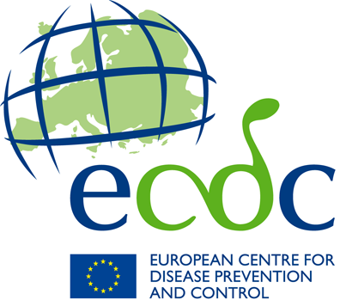

ECDC seasonal influenza communication toolkit
Influenza toolkit content
Leaflet targeting risk groups



The flu

Are you sure you use the right measure

To protect yourself against the flu?

Get vaccinated

The flu

is a serious disease

Every year the flu infects between 5% and 15% of the population. For most people, a flu infection is just a mild or unpleasant experience, but for some it can lead to serious disease, especially for people at higher risk of flu-related complications.

If you are at higher risk, it is important that you

follow your doctor’s recommendations

to avoid serious flu-related complications.

Risk groups include elderly people and those with chronic medical condition such as:

• asthma and other respiratory diseases
• diabetes and other endocrine diseases
• heart diseases
• kidney diseases
• liver diseases
• metabolic diseases
• neurological diseases
• weakened immune system (due to disease or treatment)

What are the symptoms?

Seasonal flu is caused by human influenza viruses which infects the airways (nose, throat, bronchi and sometimes lungs). Though some infections can be very mild, people who catch the flu often experience some or all of these symptoms:
• fever
• sore throat
• runny nose
• dry cough
• fatigue
• headache
• muscle ache
Complications can include pneumonia, ear infection, sinus infection, dehydration and worsening of chronic medical conditions, such as congestive heart failure, asthma, or diabetes. In elderly people, flu can sometimes cause and/or worsen certain heart conditions which could then result in heart attacks and strokes.

How can I catch the flu?

The flu mostly spreads from person to person:
• By direct contact through droplets from an infected person coughing or sneezing.
• By indirect contact when droplets or secretions from the nose or throat settle on surface areas such as hands. From there the virus can be transferred to other people who then touch their face.

What can I do to protect myself against the flu?

How to keep yourself and others healthy this winter:
• Get vaccinated before the flu season starts
Getting vaccinated every autumn greatly reduces your chance of getting the flu. Effectiveness of the vaccine may vary from year to year depending on which viruses circulate each season. The flu vaccine does not contain any living flu virus. This means that it cannot cause flu or any other infections.
Other preventive measures to limit the spread of flu are:
• Wash your hands regularly with soap and water
• Cover your mouth and nose with a tissue when you sneeze.
• Bin your used tissue
Do not reuse handkerchiefs or tissues. The flu virus can temporarily survive outside the body, so you can get infected by touching used handkerchiefs and tissues.
• If you do not have a tissue available:
Sneeze into your arm, covering totally your nose and mouth
• Stay at home when you are ill
If you get worse, seek medical help.

When should I get vaccinated?

Vaccination should ideally be undertaken starting from mid-Autumn each year. Depending on the virus circulating each year, the flu season generally lasts from October until May.

Why do I need a flu vaccine every year?

Flu viruses are constantly changing and it is not unusual for new flu viruses to appear each year. Getting vaccinated each year is the single most effective prevention against seasonal flu.

The spread of flu and its impact in Europe is constantly being monitored by

The European Influenza Surveillance Network (EISN)

coordinated by the

European Centre for Disease Prevention and Control (ECDC)

